





MongoDB is a source-available, cross-platform, document-oriented database program. Classified as a NoSQL database product, MongoDB utilizes JSON-like documents with optional schemas. MongoDB is developed by MongoDB Inc. and current versions are licensed under the Server Side Public License (SSPL). MongoDB is a member of the MACH Alliance.

MongoDB supports field, range query and regularexpression searches. Queries can return specific fields of documents and also include user-defined JavaScript functions. Queries can also be configured to return a random sample of results of a given size.

Fields in a MongoDB document can be indexed with primary and secondary indices.

WHAT IS DATABASE?

The software that interacts with end users, applications, and the database itself to capture and analyze the data. The DBMS additionally encompasses the core facilities provided to administer the database. The sum total of the database, the DBMS and the associated applications can be referred to as a database system. Often the term "database" is also used loosely to refer to any of the DBMS, the database system or an application associated with the database.

**What is MongoDB?**

MongoDB is a document database built on a horizontal scale-out architecture that uses a flexible schema for storing data. Founded in 2007, MongoDB has a worldwide following in the developer community.

Instead of storing data in tables of rows or columns like SQL database, each record in a MongoDB database is a document described in BSON, a binary representation of the data. Applications can then retrieve this information in a JSON format.

Here’s a simple JSON document describing a historical figure:

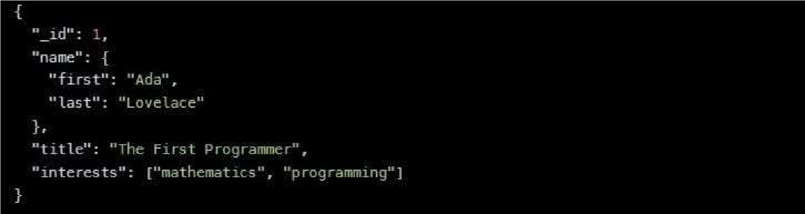

Document databases are highly flexible, allowing variations in the structure of documents and storing documents that are partially complete. One document can have others embedded in it. Fields in a document play the role of columns in a SQL database, and like columns, they can be indexed to increase search performance.

From its founding, MongoDB was built on a scale-out architecture, a structure that allows many small machines to work together to create fast systems and handle huge amounts of data.

MongoDB has always focused on providing developers with an excellent user experience, which, in addition to all its other properties, has made MongoDB a favorite of developers worldwide for a wide variety of applications.

Why Use MongoDB?

MongoDB is built on a scale-out architecture that has become popular with developers of all kinds for developing scalable applications with evolving data schemas.

As a document database, MongoDB makes it easy for developers to store structured or unstructured data. It uses a JSON-like format to store documents. This format directly maps to native objects in most modern programming languages, making it a natural choice for developers, as they don’t need to think about normalizing data. MongoDB can also handle high volume and can scale both vertically or horizontally to accommodate large data loads.

MongoDB was built for people building internet and business applications who need to evolve quickly and scale elegantly. Companies and development teams of all sizes use MongoDB for a wide variety of reasons.

**DOCUMENTAL MODEL**



The [document](https://www.mongodb.com/document-databases) data model is a powerful way to store and retrieve data in any modern programming language, allowing developers to move quickly.

***Deployment Options***



MongoDB is available in any major public cloud (such as AWS, Azure, and Google Cloud) through MongoDB Atlas, in large data centers through the Enterprise Advanced edition, or free through the sourceavailable Community edition.

***Get Started Quickly***



MongoDB has a great user experience for developers who can install MongoDB and start writing code immediately.

***Fully Scalable***



MongoDB’s horizontal, scale-out architecture can support huge volumes of both data and traffic.

**Find Community**



MongoDB has developed a large and mature platform ecosystem. It has a worldwide community of developers and consultants, making it easy to get help. It also has an enterprise-grade support offering.

Using MongoDB enables your team to go further and faster when developing software applications that handle data of all sorts in a scalable way.

MongoDB is an excellent choice if you need to: Support rapid iterative development. Enable collaboration of a large number of teams. Scale to high levels of read and write traffic. Scale your data repository to a massive size. Evolve the type of deployment as the business changes. Store, manage, and search data with text, geospatial, or time-series dimensions.

MongoDB as a company has grown because the number of use cases with these characteristics continues to grow.

**What are the Advantages of MongoDB?**

MongoDB has become one of the most wanted databases in the world because it makes it easy for developers to store, manage, and retrieve data when creating applications with most programming languages.

To understand whether MongoDB is right for you, let’s look at the advantages of MongoDB for developers. You can also check out the top five MongoDB features.

The Power of Document-Oriented Databases

MongoDB is the pioneer of what has come to be called NoSQL databases, which developed because RDBMS systems based on SQL did not support the scale or rapid development cycles needed for creating modern applications.

NoSQL is an umbrella term; it includes document-oriented databases like MongoDB, columnar databases, in-memory databases, and more.

In MongoDB, records are stored as documents in compressed BSON files. The documents can be retrieved directly in JSON format, which has many benefits:

It is a natural form to store data.

It is human-readable.

Structured and unstructured information can be stored in the same document.

You can nest JSON to store complex data objects.

JSON has a flexible and dynamic schema, so adding fields or leaving a field out is not a problem.

Documents map to objects in most popular programming languages.

Most developers find it easy to work with JSON because it is a simple and powerful way to describe and store data.

Perhaps most importantly, the developer controls the database schema. Developers adjust and reformat the database schema as the application evolves without the help of a database administrator. When needed, MongoDB can coordinate and control changes to the structure of documents using schema validation.

MongoDB created Binary JSON format (BSON) to support more data types than JSON. This new format allows for faster parsing of the data. Data stored in BSON can be searched and indexed, tremendously increasing performance. MongoDB supports a wide variety of indexing methods, including text, decimal, geospatial, and partial.

# MONGODB INSTALLATION:

Requirements to Install MongoDB on Windows

**MongoDB 4.4** and later only **support 64-bit versions** of Windows.

MongoDB 7.0 Community Edition supports the following **64-bit versions** of Windows on x86\_64 architecture:

**Windows Server 2022**

**Windows Server 2019**

**Windows 11**

Ensure that the user is running **mongod** and **mongos** has the necessary permissions from the following groups:

Performance Monitor Users

Performance Log Users

# STEPS TO INSTALL MONGODB:

To install MongoDB on Windows, first, download the MongoDB server and then install the MongoDB shell. The Steps below explain the installation process in detail and provide the required resources for the smooth **download and install MongoDB**

**Step 1:** Go to the [MongoDB Download Center](https://www.mongodb.com/download-center/community) to download the MongoDB Community Server.

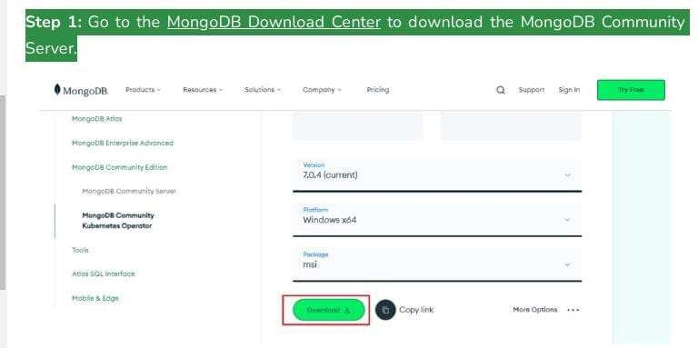

Here, You can select any version, Windows, and package according to your requirement. For Windows, we need to choose:

Version: 7.0.4

OS: Windows x64

Package: msi

Step 2: When the download is complete open the msi file and click the *next button* in the startup screen:

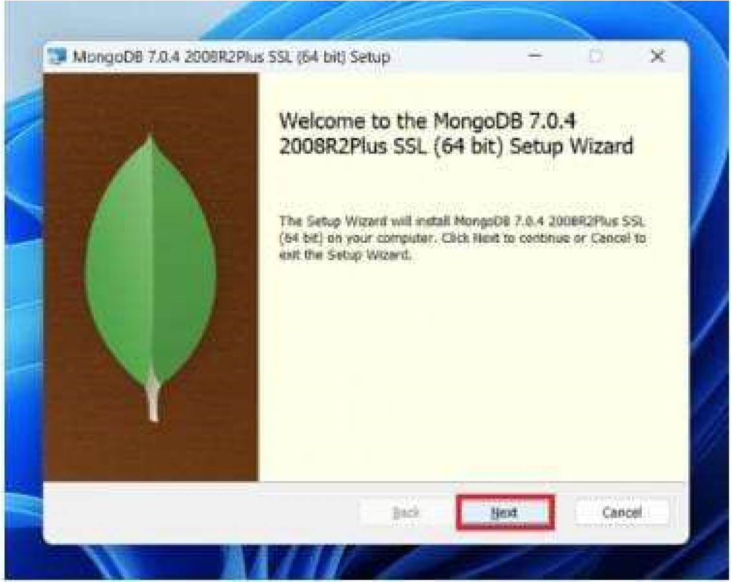

**Step 3:** Now accept the End-User License Agreement and click the next button:

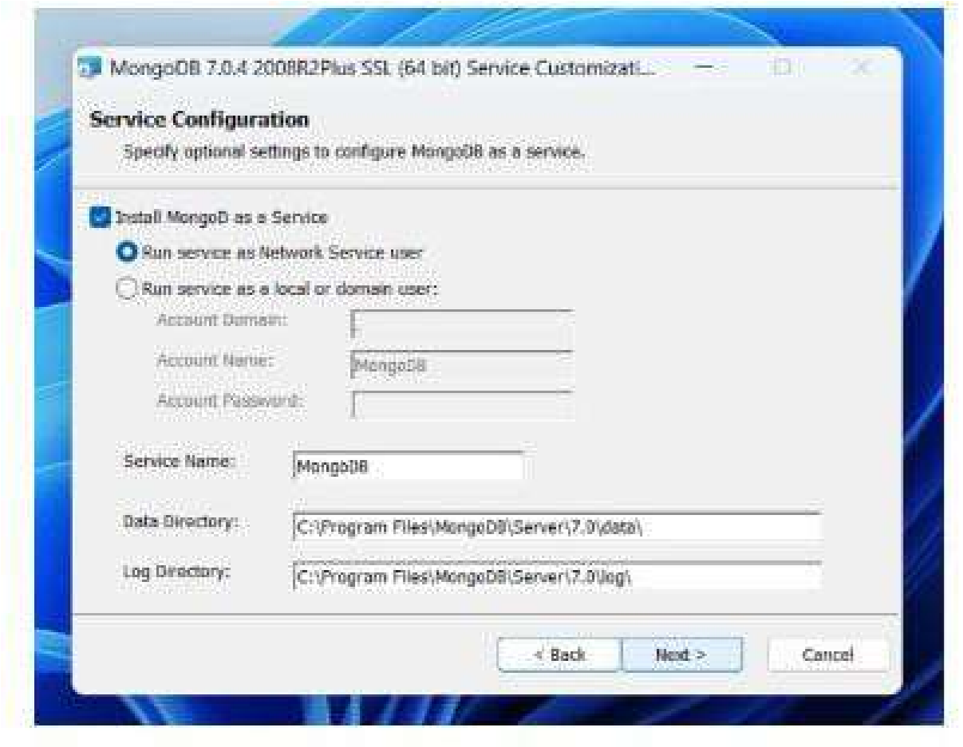

**Step 4:** Now select the *complete option* to install all the program features. Here, if you can want to install only selected program features and want to select the location of the installation, then use the *Custom option:*

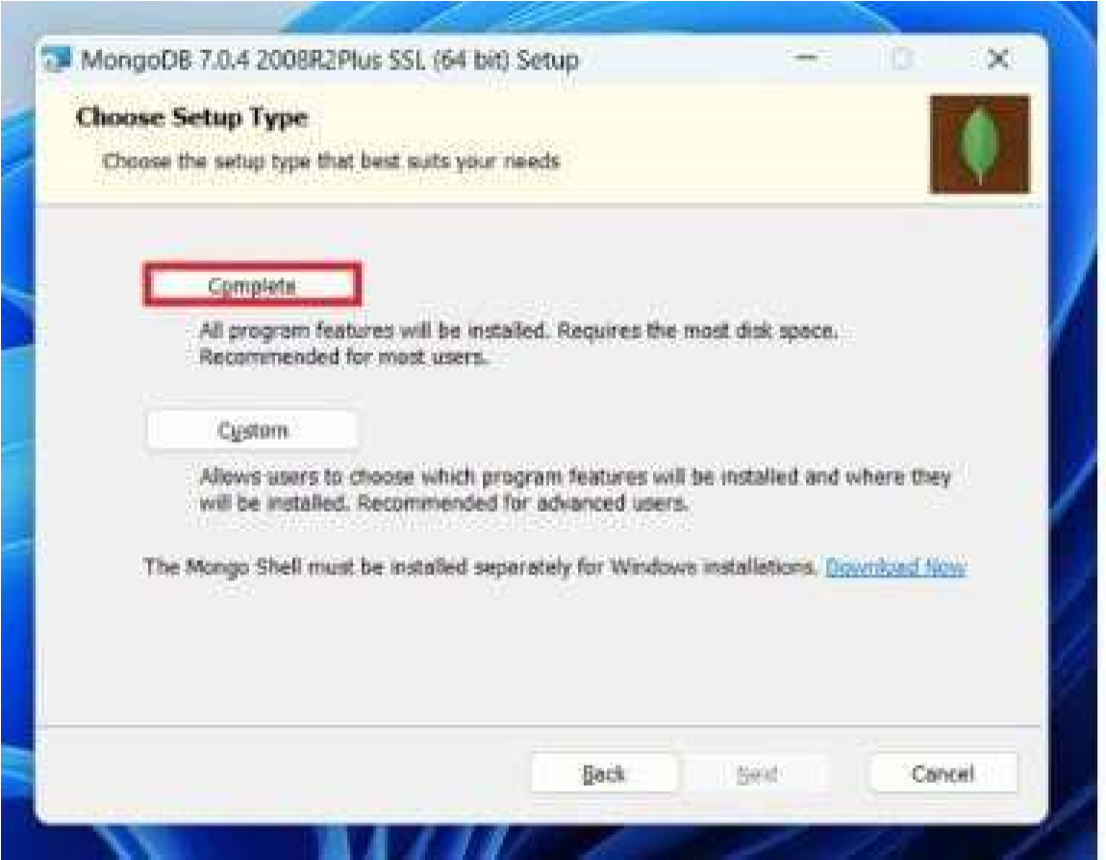

**Step 5:** Select “Run service as Network Service user” and copy the path of the data directory. Click Next:

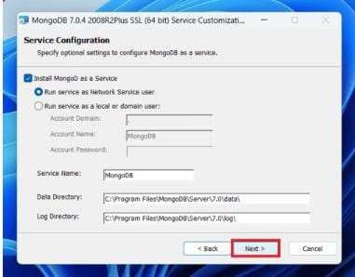

**Step 6:** Click the *Install button* to start the MongoDB installation process:

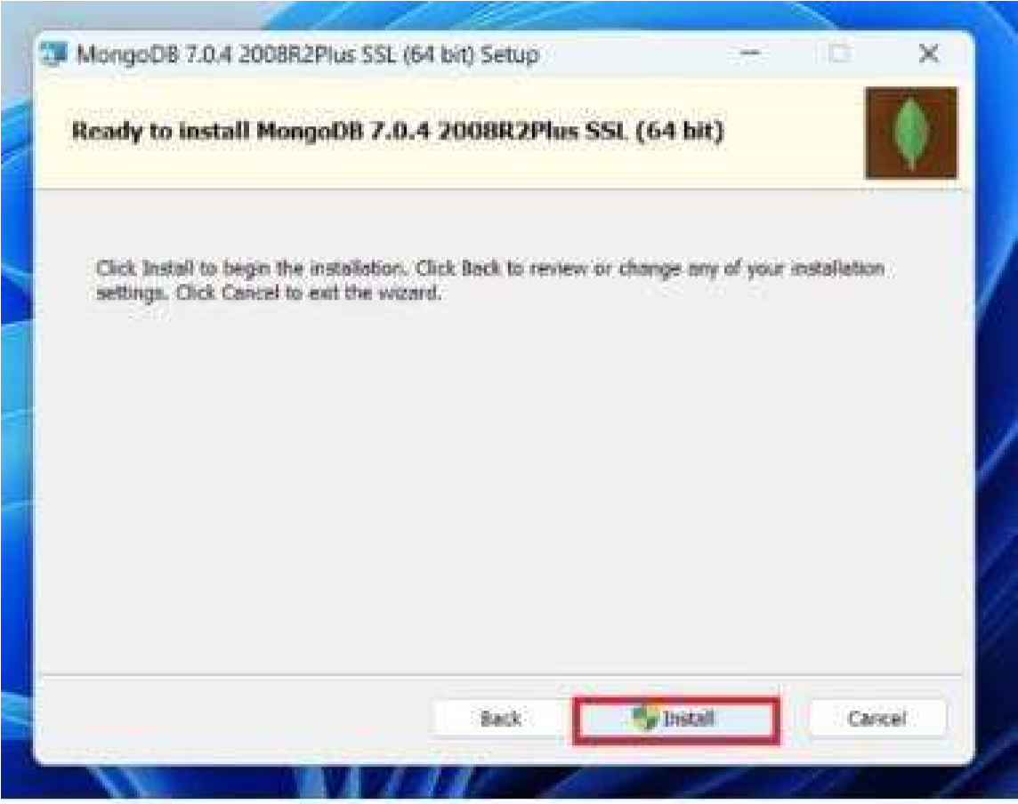

**Step 7:** After clicking on the install button installation of MongoDB begins:

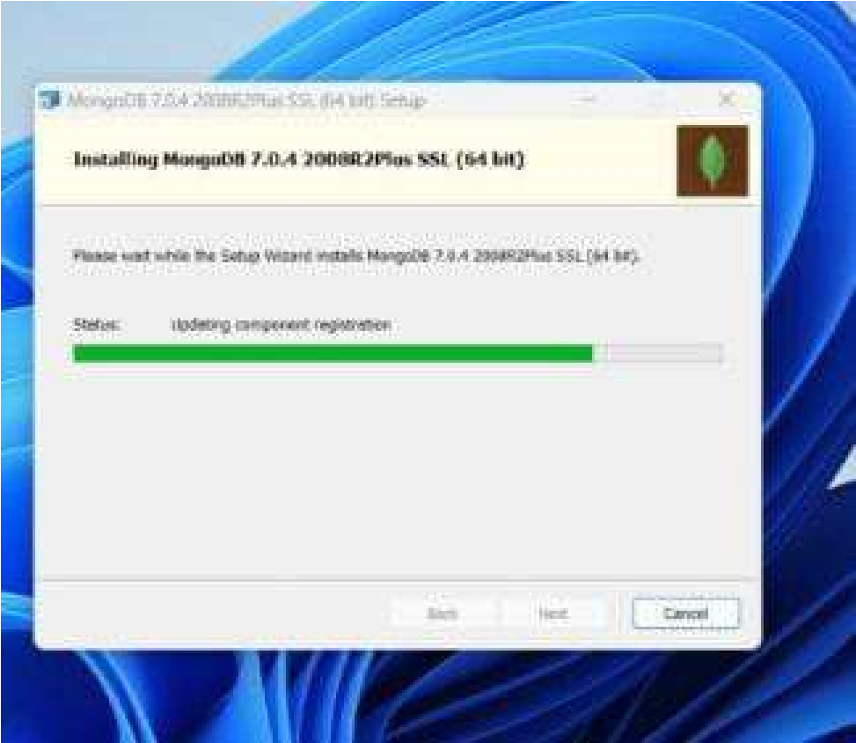

**Step 8:** Now clickthe ***Finish button***to complete the MongoDB installation process:

**Step 9:** Now we go to the location where MongoDB installed in step 5 in your system and copy the bin path:

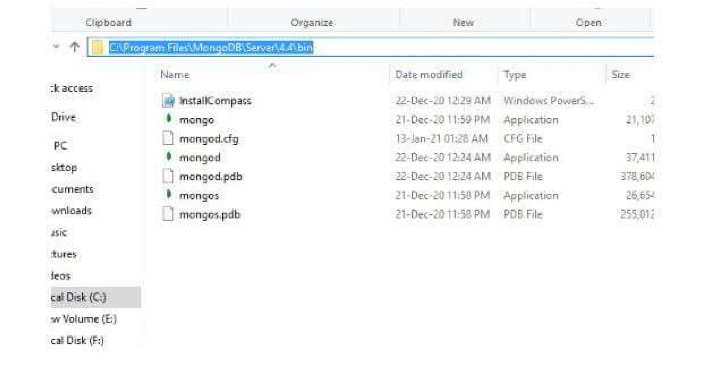

**Step 10:** Now, to create an environment variable open system properties >> Environment Variable >> System variable >> path >> Edit Environment variable and paste the copied link to your environment system and click Ok:

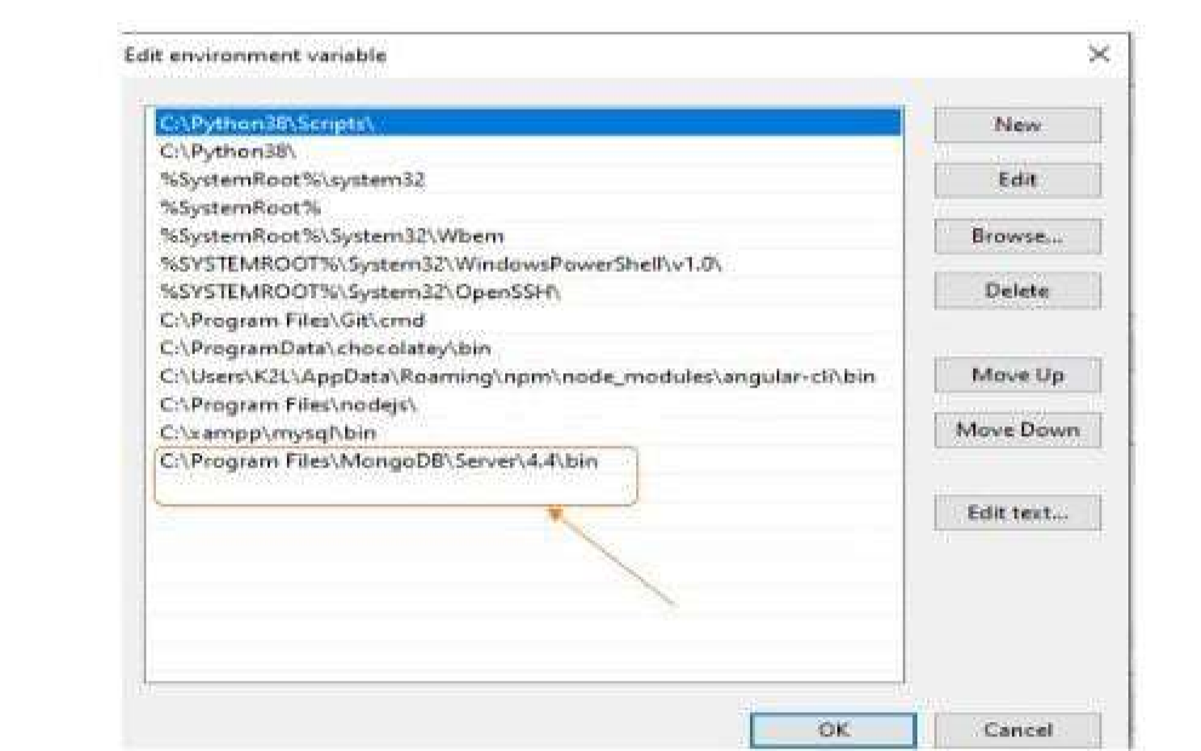

Step 11: After setting the environment variable, we will run the MongoDB server, i.e. mongod. So, open the command prompt and run the following command:  **mongod**

When you run this command you will get an error i.e. *C:/data/db/ not found*.

Step 12: Now, Open C drive and create a folder named “data” inside this folder create another folder named “db”. After creating these folders. Again open the command prompt and run the following command:

**mongod**

Now, this time the MongoDB server(i.e., mongod) will run successfully.

FEW COMMANDS:

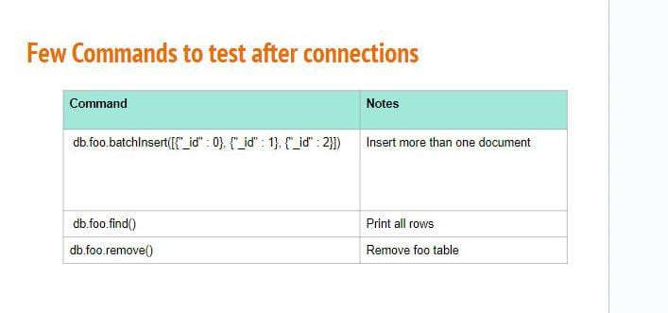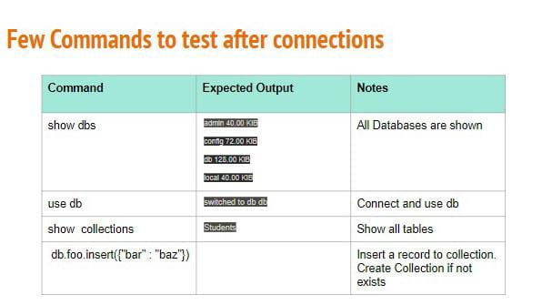

DOCUMENTS,COLLECTONS AND DATATYPES:

**DOCUMENTS:**

A record in MongoDB is a document, which is a data structure composed of field and value pairs. MongoDB documents are similar to JSON objects. The values of fields may include other documents, arrays, and arrays of documents.

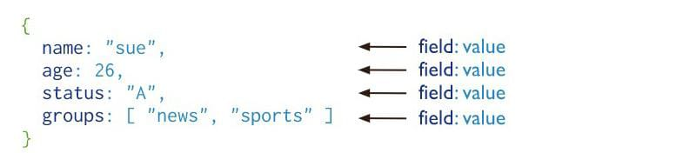

The advantages of using documents are:

1.Documents correspond to native data types in many programming languages.

2.Embedded documents and arrays reduce need for expensive joins.

3.Dynamic schema supports fluent polymorphism.

**COLLECTIONS :**

A collection is a grouping of MongoDB documents. Documents within a collection can have different fields. A collection is the equivalent of a table in a relational database system. A collection exists within a single database

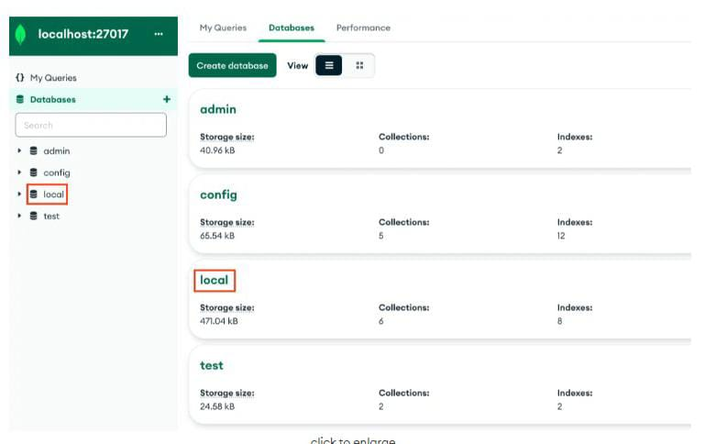

**DATATYPES:**

The datatypes are:

**1.Date**:

Mongosh provides various methods to return the date, either as a string or as a Date object:

**a**.**Date()** method which returns the current date as a string.

**b.new Date()** constructor which returns a Date object using the ISODate() wrapper.

**c.ISODate()** constructor which returns a Date object using the ISODate() wrapper.

**2.Int32**:

If a number can be converted to a 32-bit integer, mongosh will store it as Int32. If not, mongosh defaults to storing the number as a Double. Numerical values that are stored as Int32 in mongosh would have been stored by default as Double in the mongo shell.

The [Int32()](http://mongodb.github.io/node-mongodb-native/3.6/api/Int32.html) constructor can be used to explicitly specify 32-bit integers.

|  |
| --- |
| db.types.insertOne( |
| { |
| "\_id": 1, |
| "value": Int32("1"), |
| "expectedType": "Int32" |
| } |
| )  **3**.**Decimal :**  Decimal values are 128-bit decimal-based floating-point numbers that emulated ecimal rounding with exact precision.  This functionality is intended for applications that handle [monetary data](https://www.mongodb.com/docs/manual/tutorial/model-monetary-data/), such as financial, tax, and scientific computations.  The Decimal [**BSON type**](https://www.mongodb.com/docs/manual/reference/bson-types/) uses the IEEE 754 decimal128 floating-point numbering format which supports 34 decimal digits (i.e. significant digits) and an exponent range of −6143 to +6144.   |  | | --- | | db.types.insertOne( | | { | | **"\_id"**: 5, | | **"value"**: Decimal128(**"1"**), | | **"expectedType"**: **"Decimal128"** | | } | | ) | |

**4.Timestamp:**

MongoDB uses a [BSON Timestamp](https://www.mongodb.com/docs/manual/reference/bson-types/#timestamps) internally in the [oplog](https://www.mongodb.com/docs/manual/reference/glossary/" \l "std-term-oplog" \t "_self). The Timestamp type works similarly to the Java Timestamp type. Use the [Date](https://www.mongodb.com/docs/mongodb-shell/reference/data-types/#std-label-mongo-shell-date-type) type for operations involving dates.

A Timestamp signature has two optional parameters.

|  |
| --- |
| Timestamp( { **"t"**: <integer>, **"i"**: <integer> } ) |

**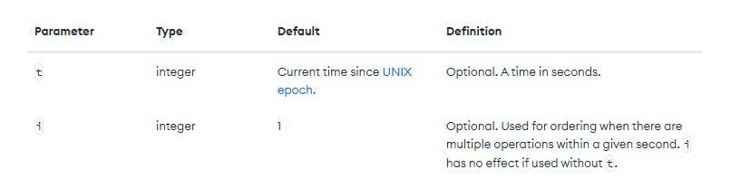**

**DATABASES:**

In MongoDB, databases hold one or more collections of documents.

To select a database to use, log in to Atlas and do the following:

1.Navigate to the *Collections* tab.

2.Select the database from the list of databases in the left pane.

**Create a Database**

To create a new database, log in to Atlas and do the following:

**1.Navigate to the***Collections***tab.**

**2.Click***Create Database***.**

**3.Enter the***Database Name***and the***Collection Name***.**

Enter the database and the collection name to create the database and its first collection.

**Click***Create***.**

Upon successful creation, the database and the collection displays in the left pane in the Atlas UI.